THE BEST TOOL TO CONTROL BLACK COFFEE TWIG BORER (BCTB): BOTTLE TRAPS.
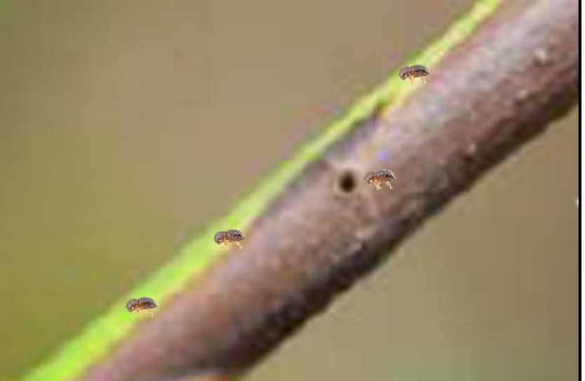 Black Coffee Twig Borers makes holes into the twigs (primary branches of a coffee tree) and stems below 2cm diameter. The twigs dry as a result of this infestation yet they are the ones that bear coffee. |  | 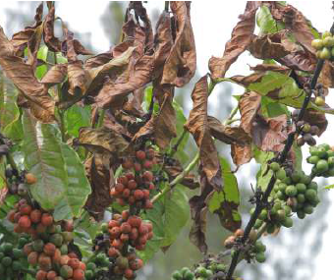  Thus yield of up to 50% can be lost if attention is not paid to its control. After very many twigs are infested on a single plant, it totally dries. |  |  | 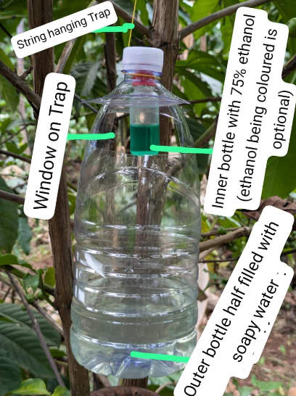
HOW TO MAKE THE BOTTLE TRAP
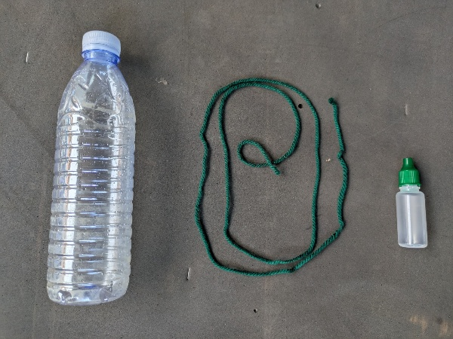 | 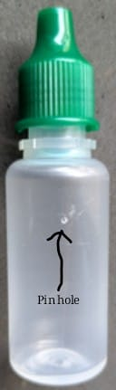 |  | 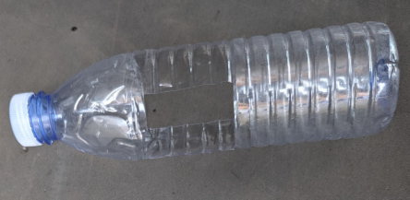 | 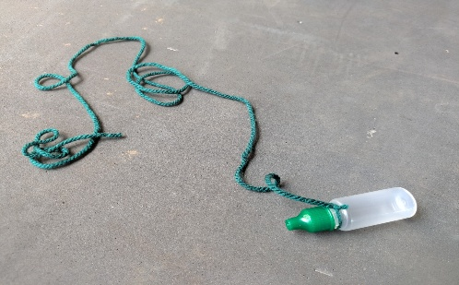 | 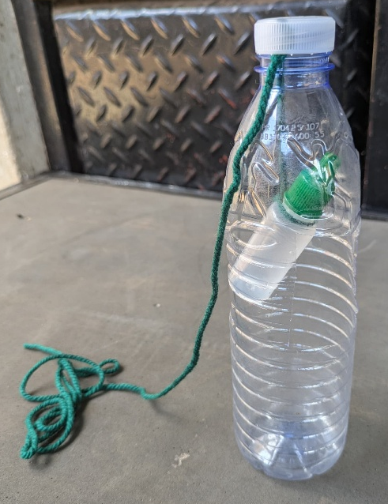
You need:  1. Plastic water bottle.  2. Small bottle such as eye drop bottle. 3. A string. | 1. Pierce one small pin hole in the smaller bottle using a pin.  2. Cut window like holes in the plastic water bottle on two opposite sides.  3. Tie the smaller bottle with a string. |  |  |  | Put the smaller bottle tied on a string inside the plastic water bottle and let the string hang by the cover of the plastic water bottle as shown in the photo.
HOW TO USE THE BOTTLE TRAP TO CONTROL BLACK COFFEE TWIG BORERS.

- Fill the Containers
  - Halfway fill the inner bottle (smaller bottler) with 75% ethanol solution. This is the bait which attracts the beetles to enter the trap.
  - Add soapy water to the outer bottle (big bottle) to half way; this soapy water will drown the beetles that enter the trap. Beetles drown easily in water which has some soap mixed in it.
- Estimating number traps required.
  - One set of traps is enough for an acre. One set has 6 bottle traps.
  - However, if the infestation is high you can use two sets of traps per acre or even 3 sets of traps.
- Install the Traps
  - Space traps evenly throughout the coffee garden
  - Mark selected trees for consistent monitoring
  - To hang a trap on a coffee tree, position it at approximately two-thirds of the height from the base of each selected tree.
  - Tie the trap securely at this height using the string
  - Ensure trap is stable and won't fall
- Regular Maintenance (Every 2 Weeks)
  - Empty and clean the water bottle (outer bottle)
  - Refill the outer bottle with soapy water
  - Empty and clean the inner bottle.
  - Refill the inner bottle with 75% ethanol.
  - Rehang the trap.
- Seasonal Considerations
  - Install traps at the beginning of rainy season
  - Monitor beetle catch rates
  - Record and document effectiveness
- Safety considerations.
- Handle ethanol solution with care.
- Do not drink it and warn all people who access the farm against drinking it. It’s dangerous.
- Keep materials away from children.
- Store extra ethanol in a safe, cool place

NB:
- Do not paint the plastic bottle red as people commonly do, BCTB traps work most effectively when the plastic bottle is left transparent.
- You can add green food colouring to the ethanol to create a visual warning system that clearly indicates the solution is not safe for consumption, helping prevent accidental ingestion by workers. Food colours are cheap and available in most supermarkets.
- Buy the smaller bottles such as eye drop bottles from plastic bottle factories or from Kikubo, contact: 0772006332 Giant Arcade for eye drop bottles.

